Name: Roma Shirodkar

Div: D15B

Roll No.: 58

Aim:To create a Lambda function which will log “An Image has been added” once you add an object to a specific bucket in S3

Theory:

An **S3 bucket** (Simple Storage Service) in AWS is a cloud-based storage service designed to store and retrieve large amounts of data, including files, images, videos, and backups. It allows users to store data in "buckets," which are like containers that can hold virtually unlimited data. S3 provides scalable, durable, and secure storage, with options for different storage classes (e.g., Standard, Glacier) based on access frequency and latency requirements. Objects (files) in S3 are identified by unique keys and organized into folders. S3 is also highly integrated with other AWS services, allowing for easy data sharing and automation.

An **AWS Lambda function** is a serverless compute service that allows users to run code without provisioning or managing servers. Lambda automatically scales in response to the number of requests, so the user only pays for the compute time consumed. It is event-driven, meaning it triggers code execution in response to specific events such as changes in an S3 bucket, HTTP requests via API Gateway, or changes in DynamoDB tables. Lambda supports several programming languages, and its architecture is ideal for building microservices, automating tasks, or processing real-time data.

Steps:

### **Create an S3 Bucket**

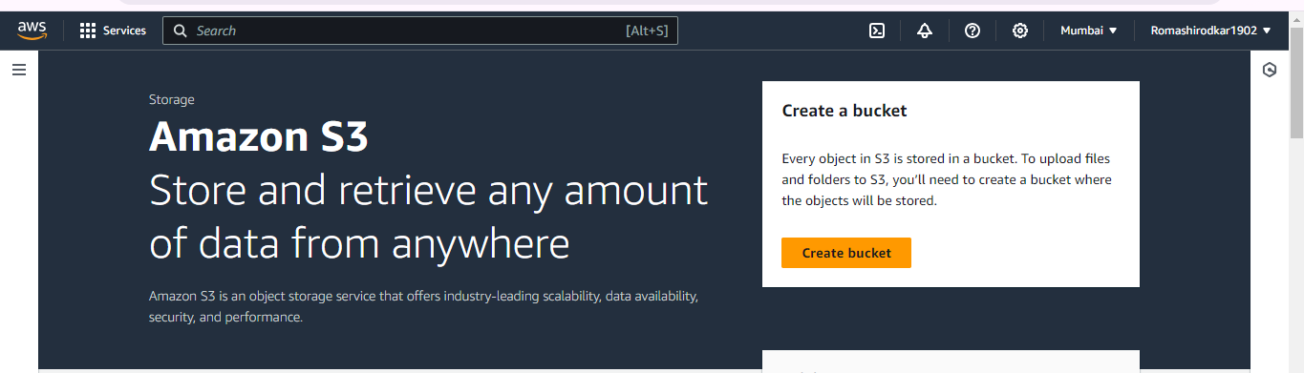

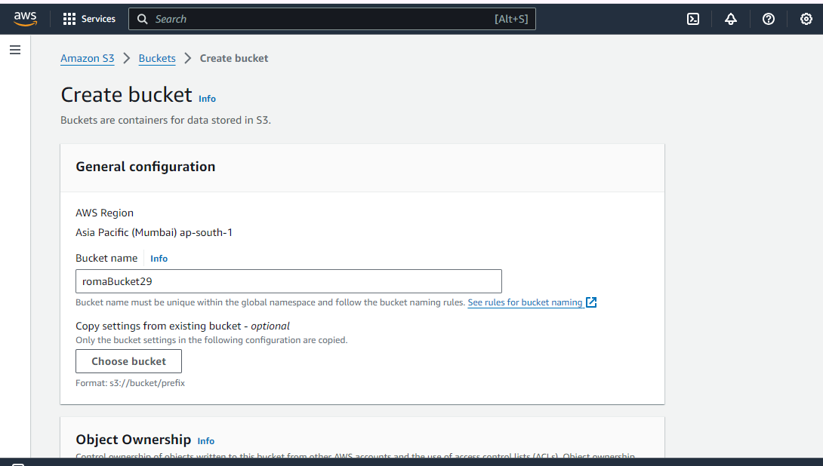

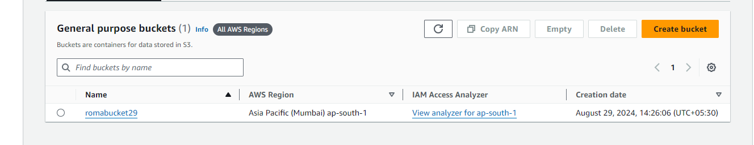

### **Create a Lambda Function**

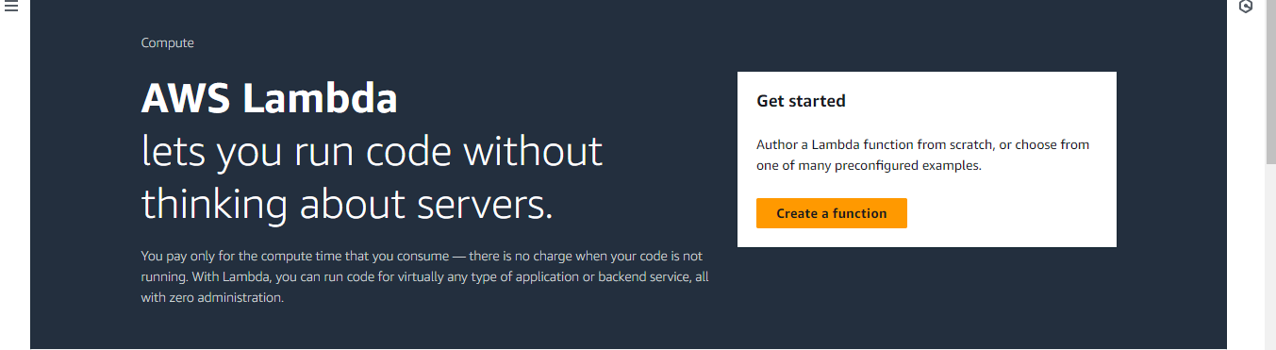

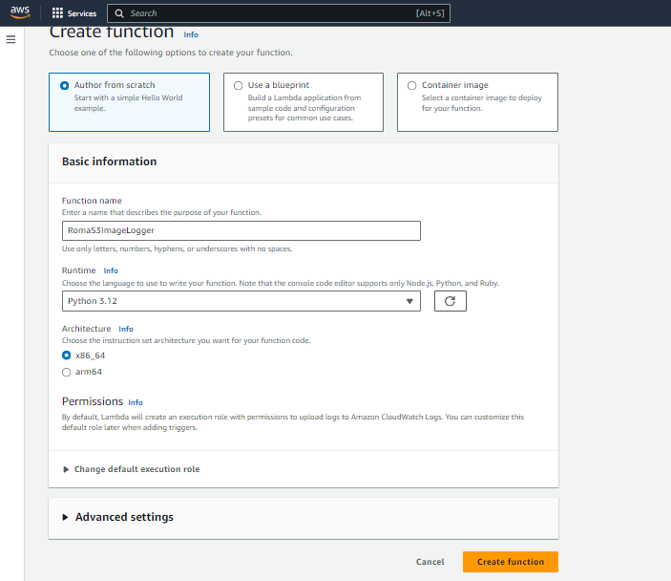

### **Write the Lambda Function Code**

* In the Lambda function console, scroll down to the code editor.

Replace the default code with the following code snippet (assuming you're using Python):  
python  
Copy code  
import json

def lambda_handler(event, context):

# Extract bucket name and object key from the event

bucket_name = event['Records'][0]['s3']['bucket']['name']

object_key = event['Records'][0]['s3']['object']['key']

# Log a message

print(f"An Image has been added to the bucket {bucket_name}: {object_key}")

return {

'statusCode': 200,

'body': json.dumps('Log entry created successfully')

}

* Click "Deploy" to save your changes.

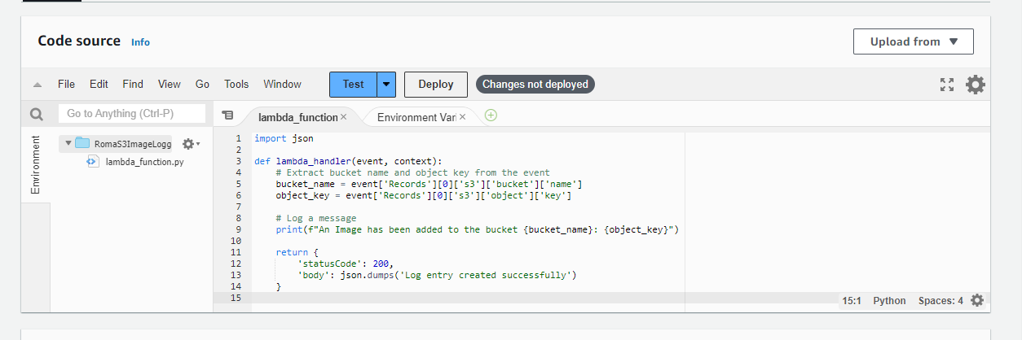

### **Set Up S3 Trigger for the Lambda Function**

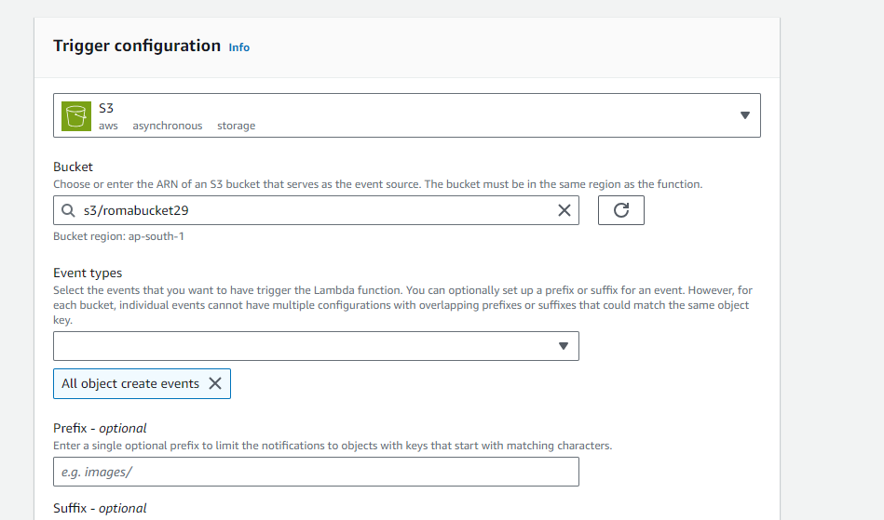

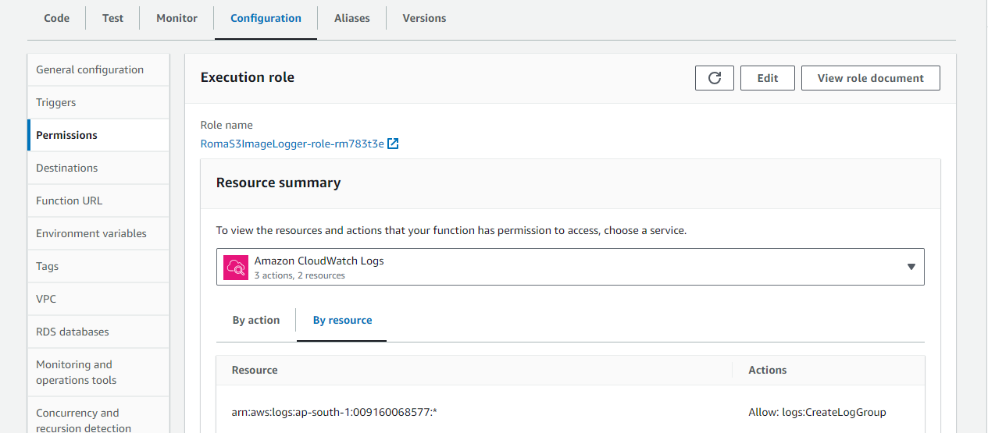

### **Test the Setup**

* Upload an image file to your S3 bucket.
* Go to the "Monitoring" tab in your Lambda function to check the logs.
* Alternatively, use CloudWatch Logs to view the output and confirm that the message "An Image has been added" has been logged.

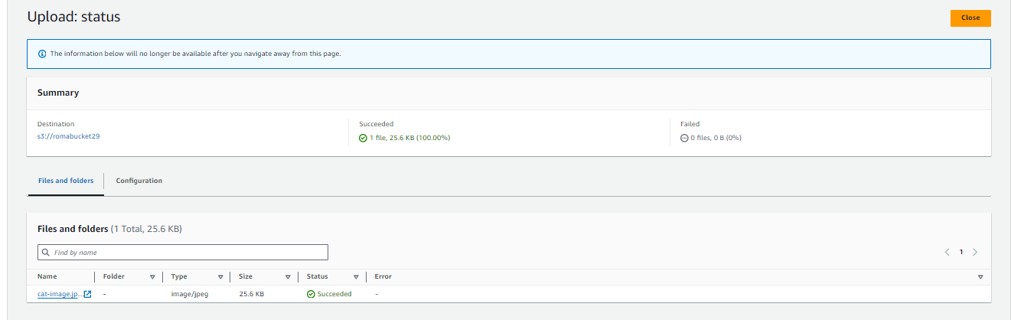

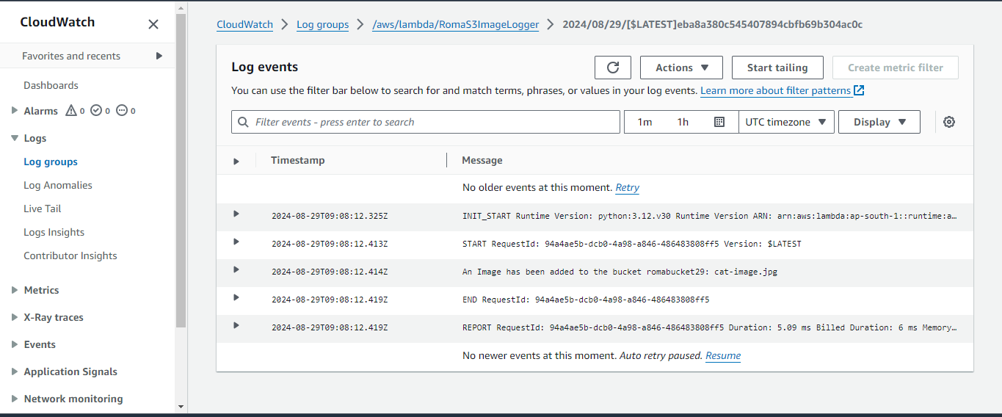

Conclusion: In conclusion, the integration between AWS S3 and Lambda provides a seamless, event-driven solution that automates tasks such as logging image uploads, enabling dynamic responses to data changes in S3 without needing a continuously running server.